**CCX Restaurant UML Diagrams**

1. **CCX Restaurant Use-Case Diagrams**
   1. **Restaurant Manager**

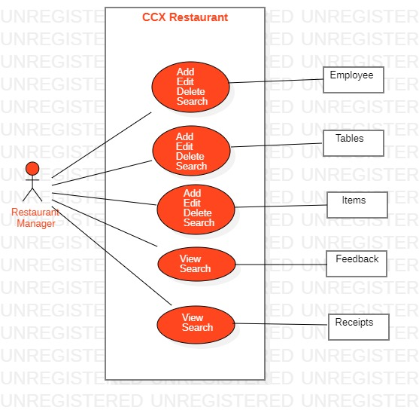

* 1. **Customer**

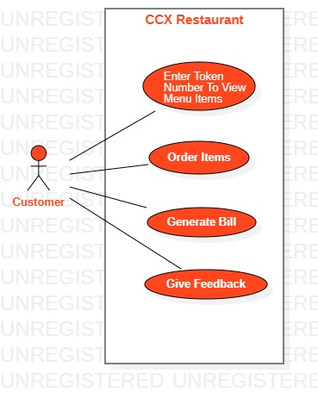

* 1. **Front Desk Manager**

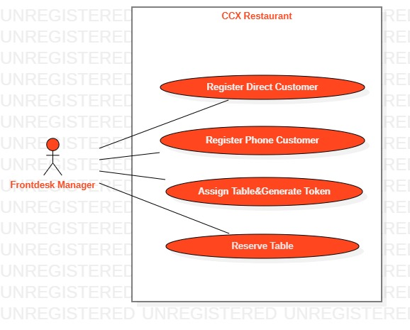

* 1. **Chef Master**

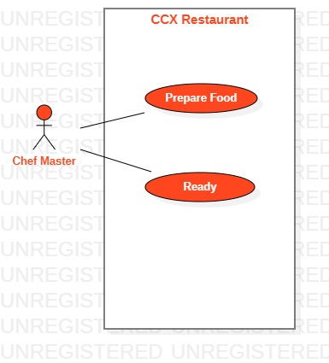

* 1. **Waiter**

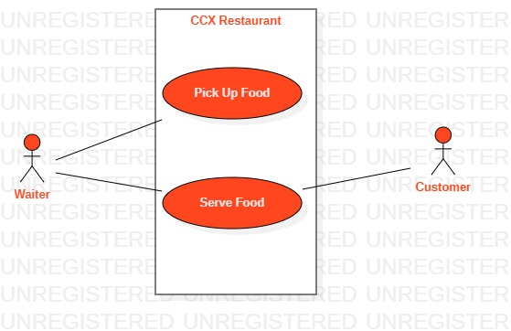

* 1. **Billing Operator**

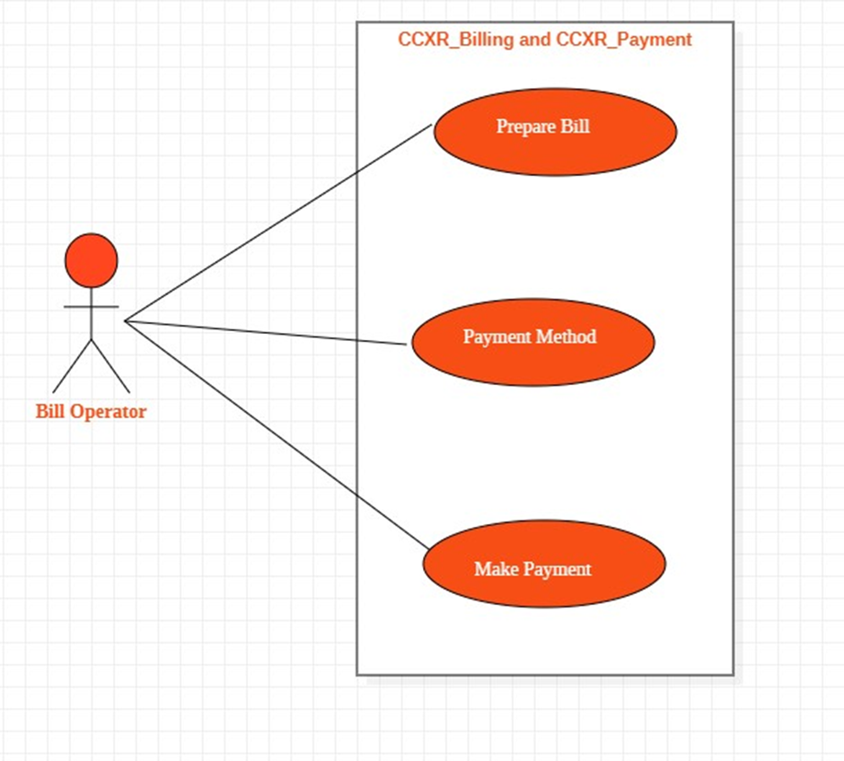

* 1. **Feedback**

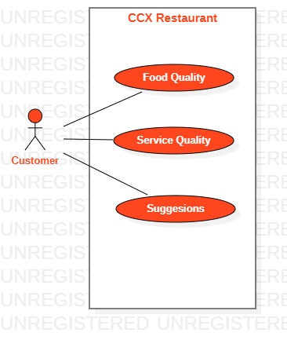

1. **CCX Restaurant Sequence Diagrams**
   1. **Restaurant Manager**

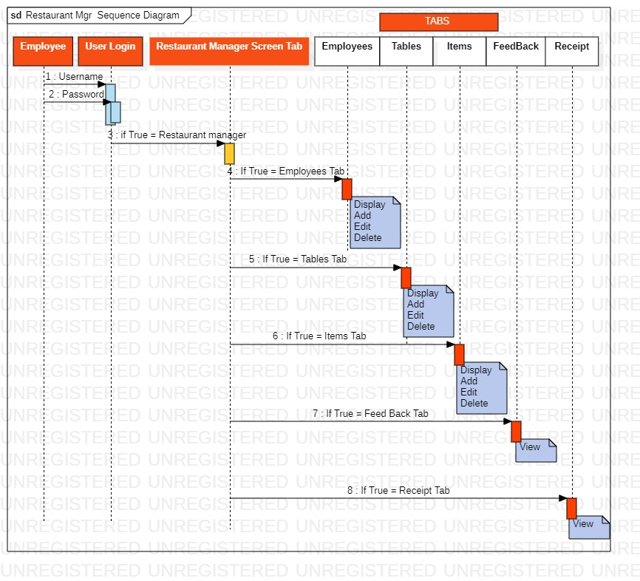

* 1. **Customer**

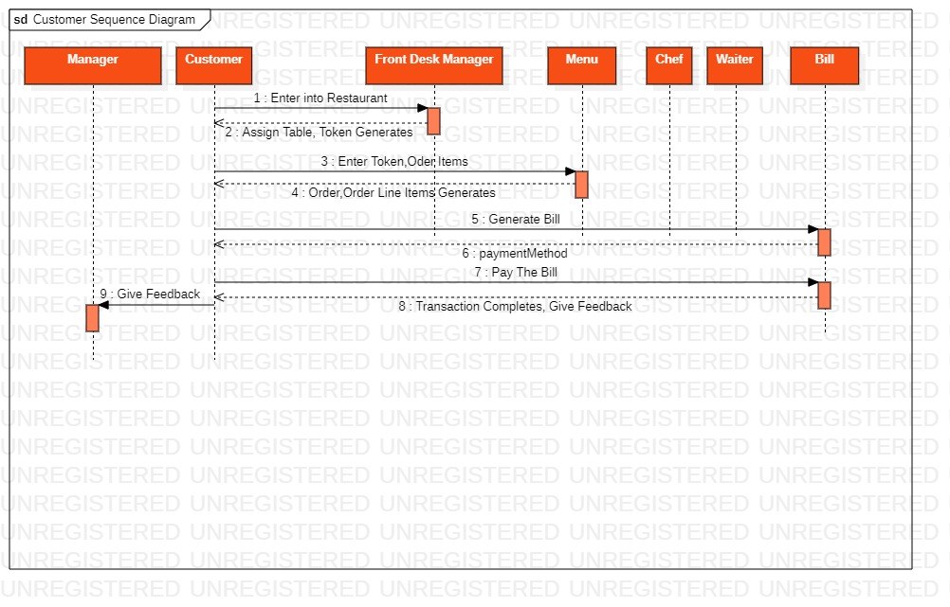

* 1. **Front Desk Manager**

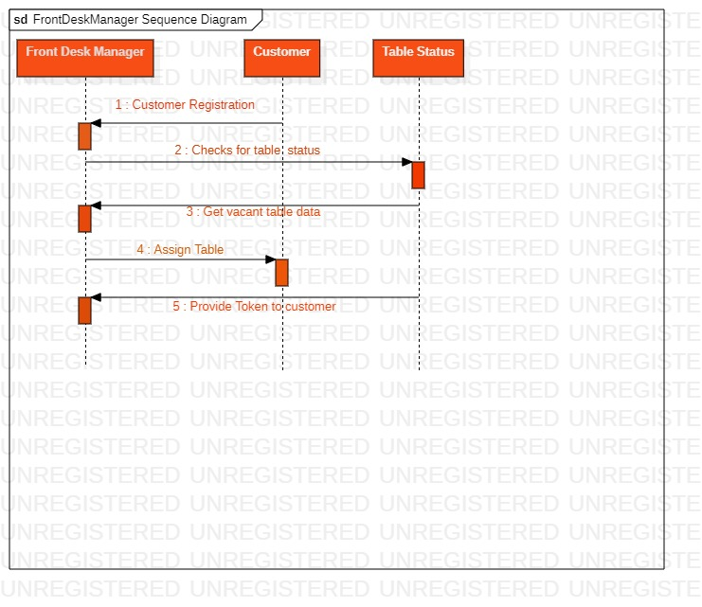

* 1. **Chef Master**

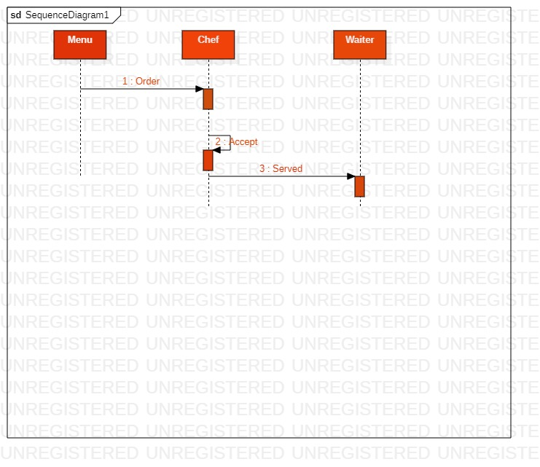

* 1. **Waiter**

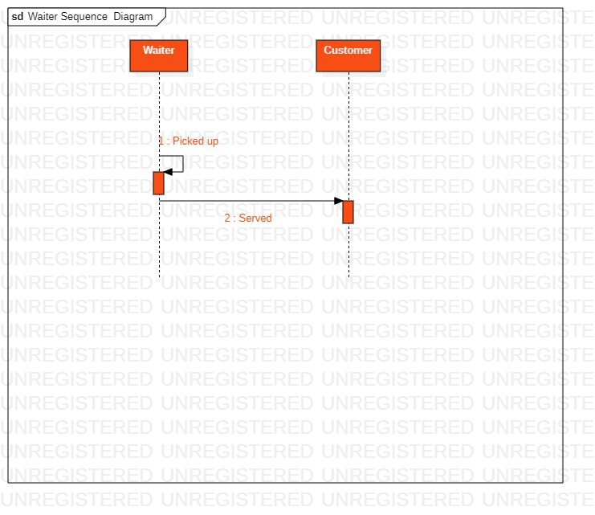

* 1. **Billing & Payment**

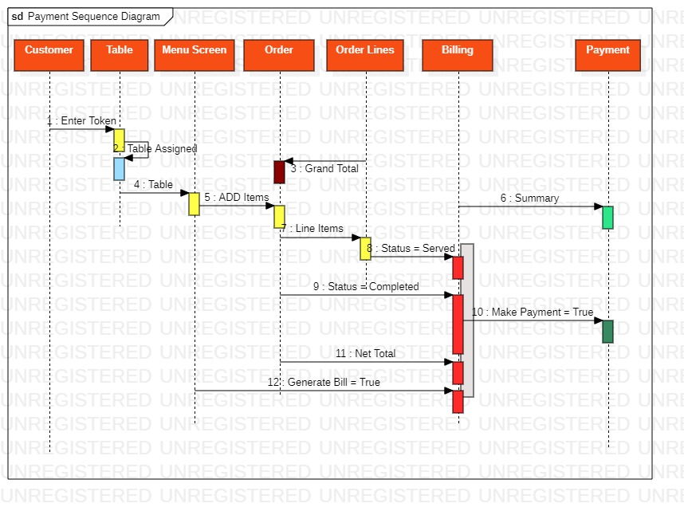

* 1. **Feedback**

